IMI October 2016  
Assignment 1  
Leonard Wan (PT DipWT6)

Introduction

Everyone loves sports one way or another. Even if we are not physically involved, we will spend some time to watch as a way to keep our minds off the stress we deal with every day. It is an activity that is enjoyable and keeps us healthy. Millions, if not billions of people around the world tune in to watch their favourite sport and teams in action every day.  
 There is also a rise in young athletes making a name for themselves in the international stage which helps promote and encourage people to take up sports. This is the reason I’m choosing ‘Sports news’ as my topic for the assignment.  
My website design will be based on 4 websites I’ve referenced, namely [www.skysports.com](http://www.skysports.com/), [www.eurosport.com](http://www.eurosport.com/), [BBC](http://www.bbc.co.uk/sport), [www.foxsports.com](https://www.google.com.sg/url?sa=t&rct=j&q=&esrc=s&source=web&cd=23&ved=0ahUKEwjWpdfvzNTPAhWLs48KHaFuBboQ-TAIjgEoADAW&url=http%3A%2F%2Fwww.foxsports.com%2F&usg=AFQjCNHh2uMeHrZ8IPv5pPpKcLer9xTQRw).

**Theme**  
The theme I’ll be using will be according to [www.skysports.com](http://www.skysports.com/), with alterations to the design, as I prefer its simplicity, organisation and user-friendly design.

**Design guidelines**1. Simplicity – By keeping it simple, it will be easy for users accessing the webpage to navigate through what they’re looking for. Productions, S. (2016)

2. Accessibility – Resolution of the website adjusts to the user’s screen resolution to create a user-friendly site. People now access the web from smartphones to desktop computers.   
Friedman, V. (2008, January 31)

3. Consistency – Keeping certain contents/designs on every page they visit would be recommended so it won’t feel as if they visit another website. Devaney, E. (2016, June 17).

**Technical specifications**

Bootstrap - Tables, navigation

Storyboard

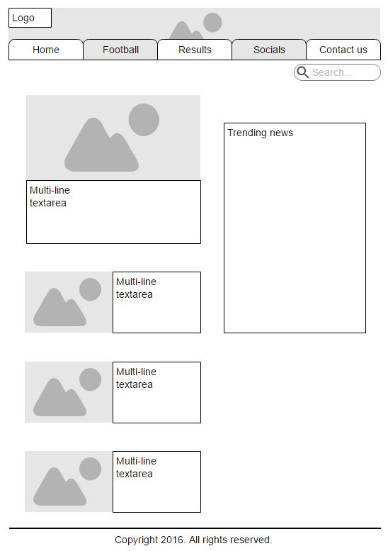

**Home**

In the home page, images will be featured along with their respective write-ups of its individual stories, commonly breaking news or top stories. There is also a ‘Search’ button to find related stories depending on what is being searched. For the convenience of users, there will be a list of trending news the people around the world are sharing, may not be related to the news provided by us.

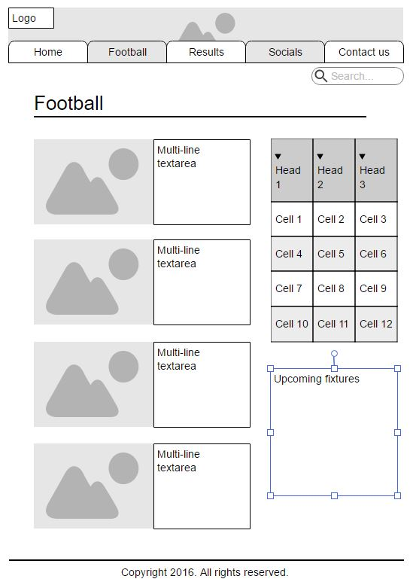

**Football**

In the football page, most elements are similar to the home page. But there’s now a header, a standing of ranks and upcoming fixtures. In this page, users can choose which league of football news they wish to view.

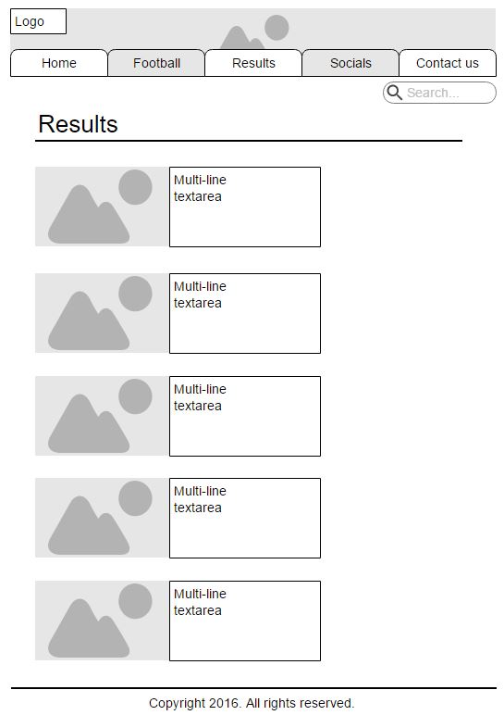

**Results**

In the results page, it is plain and everything is straightforward and simple. Users choose which league of results they would like to view and will be directed to the page.

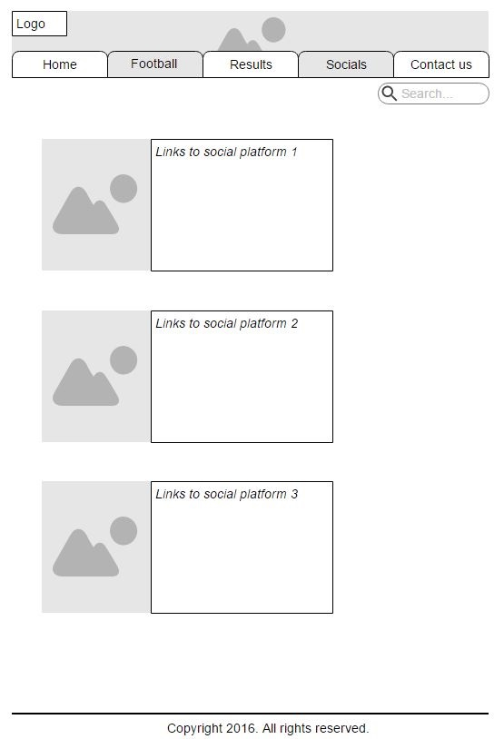

**Socials**

The socials page, the simplest design amongst all, only guiding users to its respective social media platform pages. (e.g. Facebook, Twitter, YouTube)

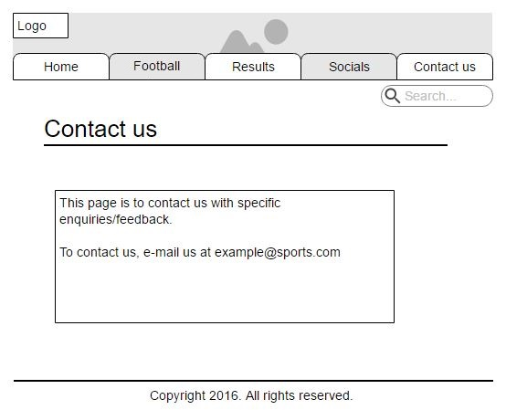

**Contact us**

In the contact us page, any details for contacting the admin will be available. For example, when the user clicks on the e-mail address of the page, a new window will pop-up for the user to write the necessary feedbacks and enquiries.

References:

Friedman, V. (2008, January 31). 10 principles of effective web design – smashing magazine. Retrieved October 13, 2016, from UX Design, <https://www.smashingmagazine.com/2008/01/10-principles-of-effective-web-design/>

Devaney, E. (2016, June 17). 8 guidelines for exceptional web design, usability, and user experience. Retrieved October 13, 2016, from <http://blog.hubspot.com/blog/tabid/6307/bid/30557/6-Guidelines-for-Exceptional-Website-Design-and-Usability.aspx#sm.0000agto70w0td0zu68167ph5kj47>

Productions, S. (2016). Top Ten rules of web design. Retrieved October 13, 2016, from <http://sharpened.com/web_design_rules>

Bootstrap carousel. Retrieved October 14, 2016, from <http://www.w3schools.com/bootstrap/bootstrap_carousel.asp>